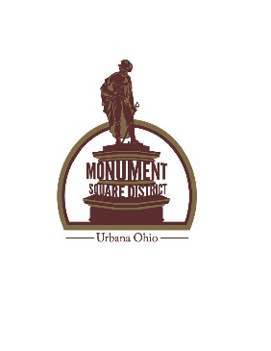

DONATION FORM

Downtown Urbana has a great need for clean, safe, well designed publicly accessible restrooms. Public restrooms are an important step in maintaining an economically vital central business district in Urbana. As such, Monument Square District and other interested individuals, groups, community leaders and businesses are seeking to raise funds to install public restroom facilities with a proposed placement at the edge of Legacy Park on the Square.
Your generous donation of any amount will be greatly appreciated. Please make checks payable to Monument Square District, Inc. As a public charity we are eligible to receive tax-deductible charitable contributions.

Name: _______________________________________________________________________________________
Address: _____________________________________________________________________________________
City/State: ____________________________________________________________________________________
Phone No.: ________________________________ *Email: _____________________________
(please provide a phone number or email address in case we have a question about your donation) *Email required for receipt
THIS CONTRIBUTION IS MADE IN HONOR OF/IN MEMORY OF:
_____________________________________________________________________________________________
Name and Address of the person to be notified of this gift:
_____________________________________________________________________________________________
_____________________________________________________________________________________________

DONATION AMOUNT: $ ____________________
Please mail your gift to:
Monument Square District
P O Box 707
Urbana, Ohio 43078
Memo Line: “Public Restrooms”

Please note that all funds donated will remain with Monument Square District should this restroom project not be completed. In that event, Monument Square District will apply the funds in accordance with our mission statement: To champion development of an economically, socially and culturally vital central business district in Urbana, OH by enhancing the quality of life of the city.

If you have any questions or concerns, please contact us at MSDUrbana@gmail.com.

