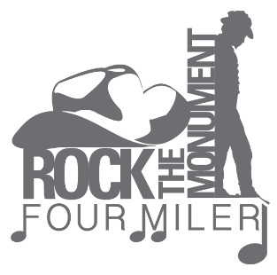
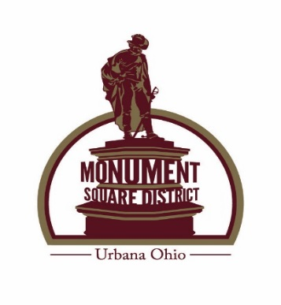
Rock the Monument Four Miler
Four Miler Run/Walk
Friday, June 9, 2023 7:00 p.m.
Melvin Miller Park
Urbana, Ohio 43078
A Monument Square District Event
All proceeds benefit our mission: to champion the vital downtown business district.

$25.00 pre-register by June 1, 2023 - includes entry and t-shirt
$25.00 after June 1, 2023 - entry only, no t-shirt
$30.00 day of race – entry only, no t-shirt
Groups of six, team lead can contact 937.215.7416 for a discount

Packet pick up and day of registration will begin at 5:30 p.m. day of race (rain or shine)
Upper Shelter House above Adult Softball Diamonds
Course is stroller and dog friendly (on a leash)

A goody bag will be given to all participants at check-in, which will include water and nutrition snacks.

Awards: Overall winners for both male and female categories, plus 2nd-4th place finishers!

***
Mail Entry Form and Entry Fee to: Monument Square District, Inc.
P O Box 707 Urbana, Ohio 43078

Name:__________________________________________________________________________

Address:____________________________________________________________________________

E:mail:________________________________________ Male:_________ Female:_________ Age on Race Day_____________
Phone Number: ___________________ T-Shirt Size________________
Emergency Contact:___________________Number:__________________
Waiver: Must be signed and dated: In consideration of my entry acceptance in the Rock the Monument Four Miler Run/Walk, I do hereby for myself, my heirs and executors, waive, release and forever discharge any and all rights and claims for damages which may hereafter occur to me against all organizations, and all legal entities affiliated with such a run for any and all injuries sustained out of my association with, entry in, participation in or travel to and from the event, I have read this form and understand the expectations of the event for which I have registered. The race will be held rain or shine.
X_________________________________________________________________________________
Signature and Date
__________________________________________________________________________________
Signature of parent/guardian if under 18 and Date

www.UrbanaOntheSquare.com www.facebook.com/MSDUrbana

